**EX.NO:1 DATE:11/9/2024**

**Reg.no:220701047**

**8- QUEENS PROBLEM**

**AIM :** To implement an 8-Queesns problem using Python.

You are given an 8x8 board; find a way to place 8 queens such that no queen can attack any other

queen on the chessboard. A queen can only be attacked if it lies on the same row, same column,

or the same diagonal as any other queen. Print all the possible configurations.

To solve this problem, we will make use of the Backtracking algorithm. The backtracking

algorithm, in general checks all possible configurations and test whether the required result is

obtained or not. For the given problem, we will explore all possible positions the queens can be

relatively placed at. The solution will be correct when the number of placed queens = 8. 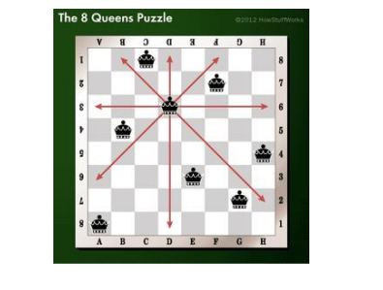

**CODE:**

N = int(input("Enter the number of queens:"))

board = [[0] * N for _ in range(N)]

def is_safe(board, row, col):

for i in range(col):

if board[row][i] == 1:

return False

for i, j in zip(range(row, -1, -1), range(col, -1, -1)):

if board[i][j] == 1:

return False

for i, j in zip(range(row, N, 1), range(col, -1, -1)):

if board[i][j] == 1:

return False

return True

def solve_nqueens(board, col):

if col >= N:

return True

for i in range(N):

if is_safe(board, i, col):

board[i][col] = 1

if solve_nqueens(board, col + 1):

return True

board[i][col] = 0

return False

if solve_nqueens(board, 0):

for row in board:

print(' '.join('Q' if x == 1 else '*' for x in row))

else:

print("No solution exists")

**RESULT:**

